Divided Kingdom Part 1

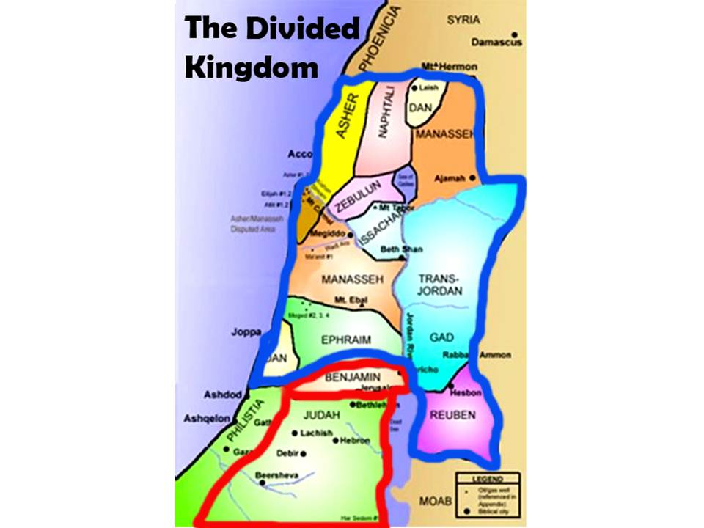

“The LORD is with you while you are with Him. If you seek Him, He will be found by you; but if you forsake Him, He will forsake you.”
2 Chron.15:2

