Lesson 5: 2 Sam.19:41-21:14
Draw a line to the correct answer:
- Sheba Threw Sheba’s head over a wall
- Joab A rebel
- Abishai Commander of David’s army
- Amasa Killed Amasa
- Wise woman of Abel Joab’s brother
Circle the correct answer:
- There was a (famine, feast) in Israel for 3 years. (2 Sam.21:1)
- God said it was because (David, Saul) had killed the Gibeonites. (2 Sam.21:1)
- The Gibeonites wanted to (hang, help) 7 members of Saul’s family. (2 Sam.21:4-6)
- David had the bones of Saul, Jonathan, and the 7 men (burned, buried) in the land of Benjamin. (2 Sam.21:13-14)
- Then, God (listened, did not listen) to the prayers of the people. (2 Sam.21:14)
Thought Questions:
- Did David inquire of the Lord when his land was troubled? What can we do in times of trouble? (2 Sam.21:1,14; Ps.55:22)
- Who were the Gibeonites? Does God keep His promises? (Josh.9, 2 Sam.21:1-14)
- Did David remember his covenant with Jonathan? (2 Sam.21:7, 1 Sam.20:14-15)

Draw a picture of Joab and Amasa:
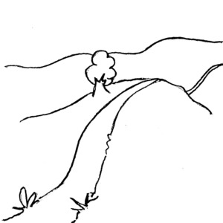

Draw a picture of the wise woman of Abel:

