Lesson 5: 2 Sam.19:41-21:14
- Did Sheba rebel against David?
- Did Joab kill Amasa?
- Did the wise woman want Joab to destroy her city?
- Did the wise woman have Sheba’s head thrown over the wall?
- Was there a famine in Israel?
- Was God happy about how the Gibeonites had been treated?
- Did David pray to God about this problem?
Draw a picture of Joab and Amasa:
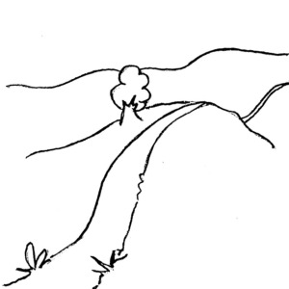

Draw a picture of the wise woman of Abel:

