Lesson 7: 2 Sam.21:15-22, 23:8-39, 1 Chron.22-29:22
- Did a giant try to kill David?
- How many fingers and toes did the giant have that David’s nephew killed?
4 5 6
- Did God allow David to build the temple?
- Did God choose Solomon to be the next king?
- Did David gather supplies to build God’s temple?
- Were the people happy to give to God?
- Did David want Solomon to serve God with a loyal heart?
IF Solomon would… (1 Chron.28)

THEN God would:(1 Chron.28)

“IF you forsake Him, He will cast you off forever.”
1 Chron.28:9

Cut and glue words in the correct heart:
Keep God’s law Give wisdom
Seek God Give land forever
Know God Give kingdom forever
Serve with loyal heart Be his Father
Carefully obey God will be found

David’s Mighty Men
Draw pictures:

Adino the Eznite killed 800 men at one time!

Eleazar killed Philistines until his hand stuck to his sword.

Shammah the son of Agee defeated Philistines alone in the middle of a bean field.
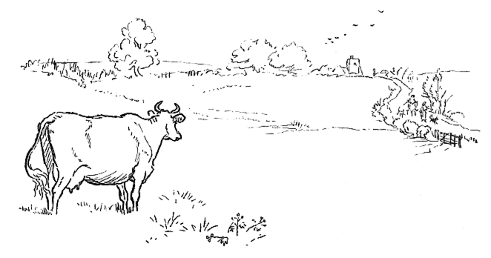

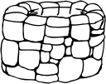
Philistines were in Bethlehem. David’s men got water for him from the well with enemies all around.

Abishai killed 300 men with his spear.

Benaiah killed a lion in a pit on a snowy day.

He also killed a 7 1/2 foot tall Egyptian man and 2 lion-like heroes of Moab!

