Bible Class Songs
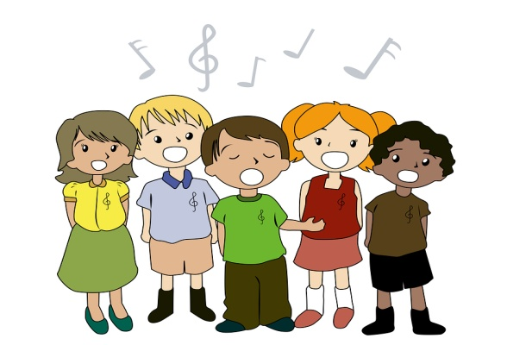

United Kingdom Part 2

Psalm 19:7-10 #439
The law of the Lord is perfect, converting the soul;
The testimony of the Lord is sure, making wise the simple;
The statutes of the Lord are right, rejoicing the heart;
The commandment of the Lord is pure, enlightening the eyes;
The fear of the Lord is clean, enduring forever;
The judgments of the Lord are true and righteous altogether.
Chorus: More to be desired are they than gold,
Yea, than much fine gold;
Sweeter also than honey and the honeycomb.
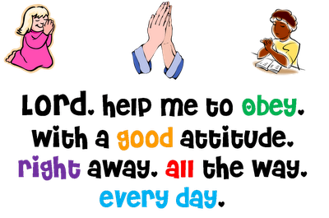
Trust And Obey #326
When we walk with the Lord in the light of His Word,
What a glory He sheds on our way!
While we do His good will, He abides with us still,
And with all who will trust and obey.
- Chorus:
Trust and obey, for there’s no other way
To be happy in Jesus, but to trust and obey.

God’s Servant Job
Where are you going, Satan?
Where have you been?
I’ve been roaming up and down the earth.
Have you considered, Satan, my servant, Job?
No one like him in all the earth.
Hear the story: Job was blameless.
Hear the story: Job was upright.
Hear the story: How he feared the Lord, turned away from evil, God’s servant Job.
Psalm 139
(To the tune of: “Twinkle, Twinkle, Little Star”)
- Does the Lord know who I am?
Yes, and much more than my name.
He knows when I wake or when I sleep,
What I think before I speak.
God knows all my history,
What has been and what will be.

- God is everywhere I go;
I can’t run from Him, oh no!
Highest heaven, deepest sea,
Darkest night cannot hide me.
With my Lord to lead the way,
Darkness is as bright as day.

- Long ago, before my birth,
God the Lord of all the earth
Saw the child that I would be,
Formed my body secretly.
I will give Him all my praise:
I have been so wonderfully made!
Ecclesiastes Song
(To the tune of: ”Nothing But The Blood”)
What can make my happiness?
Nothing but serving God.
What can make my happiness?
Nothing but serving God.
Chorus: All is vanity, vanity and grasping for the wind.
All is vanity, fear God and keep His commandments.
Eccl.1:11,12:13

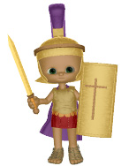
The Battle Belongs To The Lord
- In heavenly armor we'll enter the land,
The battle belongs to the Lord.
No weapon that’s fashioned against us will stand.
The battle belongs to the Lord.
- When the power of darkness comes in like a flood,
The battle belongs to the Lord!
He's raised up a standard, the power of His blood,
The battle belongs to the Lord.
- When your enemy presses in hard do not fear,
The battle belongs to the Lord!
Take courage, my friend, your redemption is near
The battle belongs to the Lord!

Chorus: And we sing glory, honor, power and strength to the Lord.
And we sing glory, honor, power and strength to the Lord.

Saints Lift Your Voices

